**Gauss’ Central Difference Formula:**

***Introduction:*** Interpolation is the process of approximating a given function, whose values are known at n+1 tabular points, by a suitable polynomial, Yn(x)of degree n which takes the values yi at x=xi for i=0,1,2………n

And the tabular points xi's are equally spaced. i.e. let

xi=x0+ph, p=0,1,2,……,n here, h=difference.

=>P=( xi-x0)/h ,where x0=middle value

***Gauss Forward Difference formula of Interpolation:***

Yp=y0+ G1Δy0+ G2Δ2y-1+ G3Δ3y-1+ G4Δ4y-2+……….

Gauss’ Forward Formula

X Y ∆ ∆2  ∆3 ∆4  ∆5  ∆6

X­-3  y-3

∆y-3

X­-2  y-2 ∆2y-3

∆y-2  ∆3y-3

X­-1  y-1 ∆2y-2 ∆4y-3

∆y-1 ∆3y-2 ∆5y-3

X­0  y0 ∆2y-1 ∆4y-2 ∆6y-3

∆y0 ∆3y-1 ∆5y-2

X­1  y1 ∆2y0 ∆4y-1

∆y1 ∆3y0

X­2  y2 ∆2y1

∆y2

X­3  y3

…. ……

G1=p,

G2=,

G3=,

G4=.

***Gauss Backward Difference formula of Interpolation:***

Yp=y0+G’1∆y-1+G’2∆2y-1+G’3∆3y-2+G’4∆4y-2+…………..

Gauss’ Backward Formula

X Y ∆ ∆2  ∆3 ∆4  ∆5  ∆6

X­-3  y-3

∆y-3

X­-2  y-2 ∆2y-3

∆y-2  ∆3y-3

X­-1  y-1 ∆2y-2 ∆4y-3

∆y-1 ∆3y-2 ∆5y-3

X­0  y0 ∆2y-1 ∆4y-2 ∆6y-3

∆y0 ∆3y-1 ∆5y-2

X­1  y1 ∆2y0 ∆4y-1

∆y1 ∆3y0

X­2  y2 ∆2y1

∆y2

X­3  y3

Where,

G’1=p,

G’2=,

G’3=,

G’4=.

The source code:

#include<bits/stdc++.h>

using namespace std;

int main()

{

int n,i,j,a,ch;

float ax[10],diff[20][20],x,y=0,yp,p,y1,y2,y3,y4,h;

printf("gauss central interpolation formula..\n");

printf("Enter the value of n:");

scanf("%d",&n);

printf("\nEnter the values:\nx y\n");

for(i=0;i<n;i++)

{

cin>>ax[i]>>diff[0][i];

}

while(1){

cout<<"1.Forward interpolation\t2.Backward interpolation\t0.Exit"<<endl;

cout<<"Enter your choice:";

cin>>ch;

if(ch==1){

printf("\nEnter the value of x for which you want the value of y:");

scanf("%f",&x);

h=ax[1]-ax[0];

a=(int)(n/2);

p=(x-ax[a])/h;

cout<<"The Difference Table"<<endl;

cout<<" X"<<" \t "<<"Y"<<"\t ";

for(i=2;i<=n;i++)

{cout<<"del_y"<<i-2<<"\t ";}

cout<<"\n";

for(i=1;i<n;i++)

{

for(j=0;j<n-i;j++)

{

diff[i][j]=diff[i-1][j+1]-diff[i-1][j];

}

}

for(j=0;j<n;j++)

{

cout<<ax[j]<<"\t";

for(i=0;i<n-j;i++)

{

cout<<fixed<<setprecision(4)<<"["<<i<<"]"<<"["<<j<<"]="<<diff[i][j]<<"\t";

}

printf("\n");

}

y1=p*diff[3][1];

y2=p*(p-1)*diff[3-1][2]/2;

y3=p*(p-1)*(p+1)*diff[3-2][3]/6;

y4=p*(p-1)*(p+1)*(p-2)*diff[3-3][4]/24;

yp=diff[0][3]+y1+y2+y3+y4;

printf("\n\nformula result=%f\n",yp);

}

else if(ch==2){

printf("\nEnter the value of x for which you want the value of y:");

scanf("%f",&x);

h=ax[1]-ax[0];

a=(int)(n/2);

p=(x-ax[a])/h;

cout<<"The Difference Table"<<endl;

cout<<" X"<<" \t "<<"Y"<<"\t ";

for(i=2;i<=n;i++)

{cout<<"del_y"<<i-2<<"\t ";}

cout<<"\n";

for(i=1;i<n;i++)

{

for(j=0;j<n-i;j++)

{

diff[i][j]=diff[i-1][j+1]-diff[i-1][j];

}

}

for(j=0;j<n;j++)

{

cout<<ax[j]<<"\t";

for(i=0;i<n-j;i++)

{

cout<<fixed<<setprecision(4)<<"["<<i<<"]"<<"["<<j<<"]="<<diff[i][j]<<"\t";

}

printf("\n");

}

y1=p*diff[1][a];

y2=p*(p+1)*diff[a-1][2]/2;

y3=p*(p-1)*(p+1)*diff[a][2]/6;

y4=p*(p-1)*(p+1)*(p+2)*diff[a+1][1]/24;

yp=diff[0][3]+y1+y2+y3+y4;

printf("\n\nBackward difference formula result=%f\n",yp);

}

else if(ch==0) {

exit(1);}

}

return 0;}

**Input/Output:**

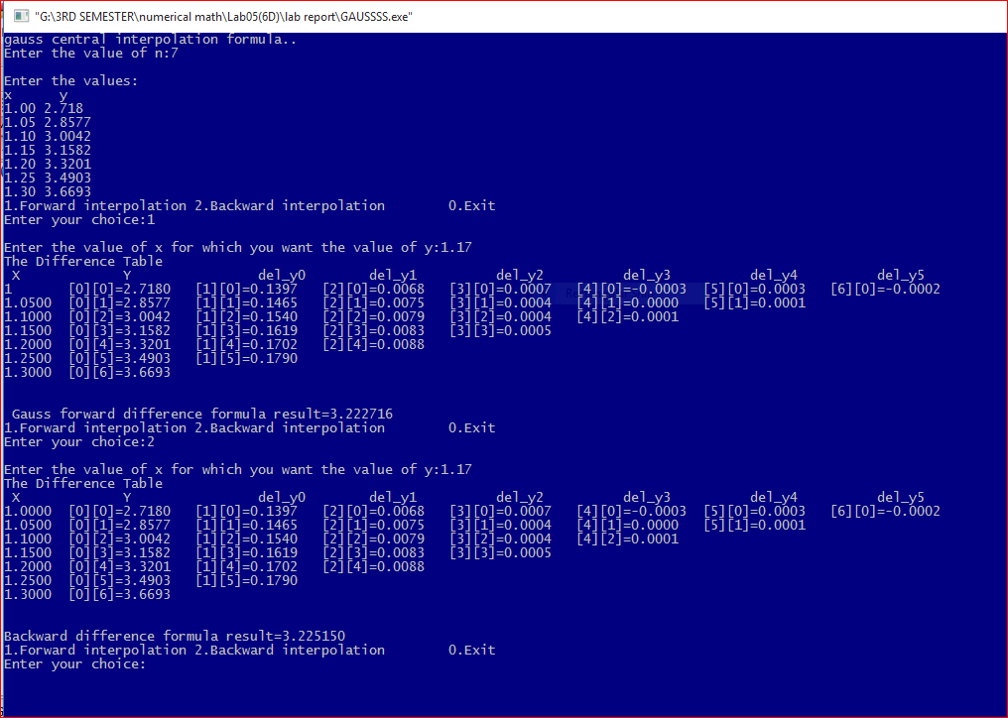

**Discussion:** Interpolation refers to the process of creating new data points given within the given set of data .The Gauss’ central difference formula is one kind of interpolation which is most suited for interpolation near the middle of a tabulated set . there is two formula-i) Gauss’ forward formula and ii) backward formula. The difference table of these two formula expresses the difference between them.